Create a collection called ‘games’. We’re going to put some games in it.

Add 5 games to the database.

Give each document the following properties: name, genre, rating (out of 100)

If you make some mistakes and want to clean it out, use remove() on your collection.

Write a query that returns all the games.

Write a query to find one of your games by name without using limit().

Use the findOne method. Look how much nicer it’s formatted!

Write a query that returns the 3 highest rated games.

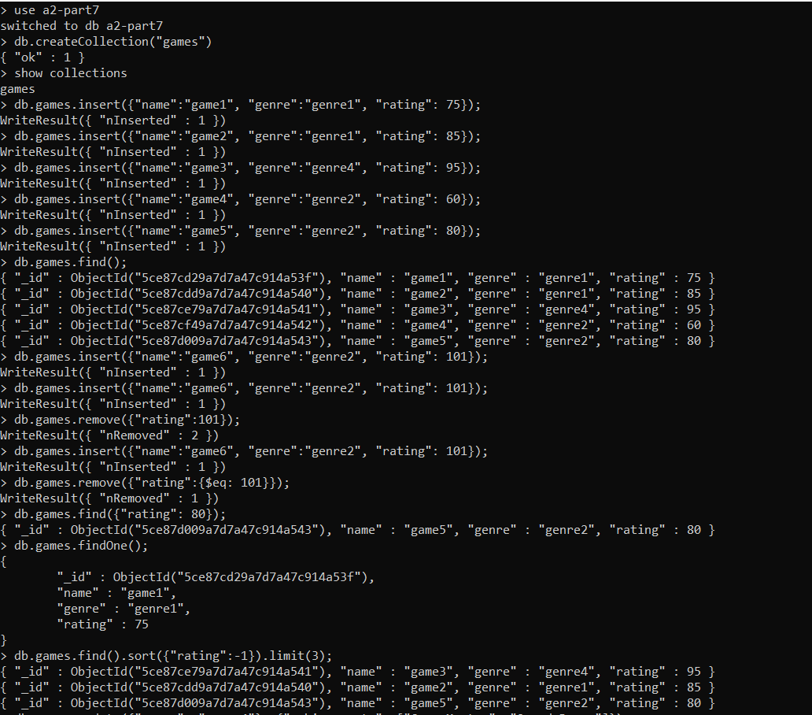

Update your two favorite games to have two achievements called ‘Game Master’ and ‘Speed Demon’, each under a single key.

Show two ways to do this. Do the first using update() and do the second using save(). Hint: for save, you might want to query the object and store it in a variable first.

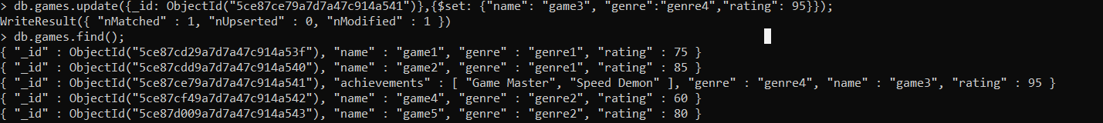

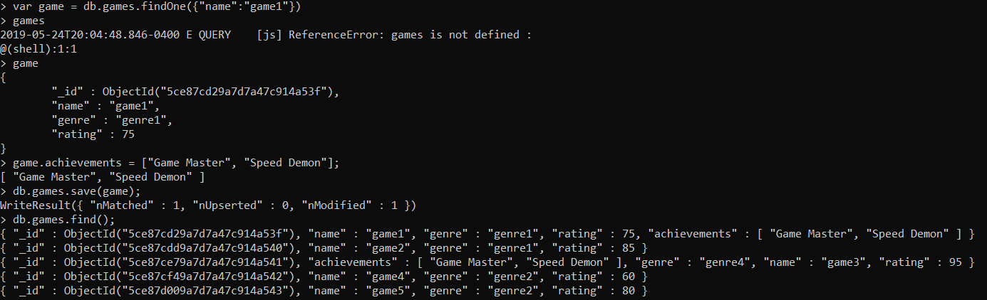

Write a query that returns all the games that have both the ‘Game Master’ and the ‘Speed Demon’ achievements.



Write a query that returns only games that have achievements. Not all of your games should have achievements, obviously.

